Student exercise 4

***This exercise to be done by the student in class***

1. Take class exercise two into consideration. Change the code where a user enters a sentence and a word to check within that sentence.

Output should be as follow:

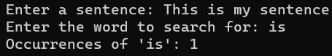

1. Take class exercise three into consideration. Change the code where a user enters a sentence and a word to look for to change.

Output should be as follow:

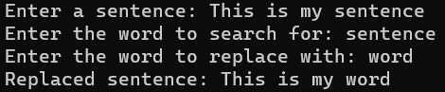

1. Take class exercise four into consideration. Change the code to accept a sentence from a user, the letter to change and what it must be changed to.

Output should be as follow:

